**Testing**

1. **Testing Strategies And Test Conditions**

# Testing Strategies And Case Conditions

Software testing can be stated as the process of verifying and validating that a software or application is bug free, meets the technical requirements as guided by it’s design and development and meets the user requirements effectively and efficiently with handling all the exceptional and boundary cases.

The process of software testing aims not only at finding faults in the existing software but also at finding measures to improve the software in terms of efficiency, accuracy and usability. It mainly aims at measuring specification, functionality and performance of a software program or application.

# **Software testing can be divided into two steps:**

1. **Verification:** It refers to the set of tasks that ensure that software correctly implements a specific function.
2. **Validation:** It refers to a different set of tasks that ensure that the software that has been built is traceable to customer requirements.

**Verification:** “Are we building the product right?”  
**Validation:** “Are we building the right product?”

### Principles of Testing

# All the test should meet the customer requirements.

# To make our software testing should be performed by third party.

# Exhaustive testing is not possible.As we need the optimal amount of testing based on the risk assessment of the application.

# All the test to be conducted should be planned before implementing it.

# It follows pareto rule(80/20 rule) which states that 80% of errors comes from 20% of program components.

# Start testing with small parts and extend it to large parts.

# Types of Testing Took Place in This Project Cycle

## Unit Testing

It focuses on smallest unit of software design. In this we test an individual unit or group of inter related units.It is often done by programmer by using sample input and observing its corresponding outputs.

**Example:**

a) In a program we are checking if loop, method or

function is working fine

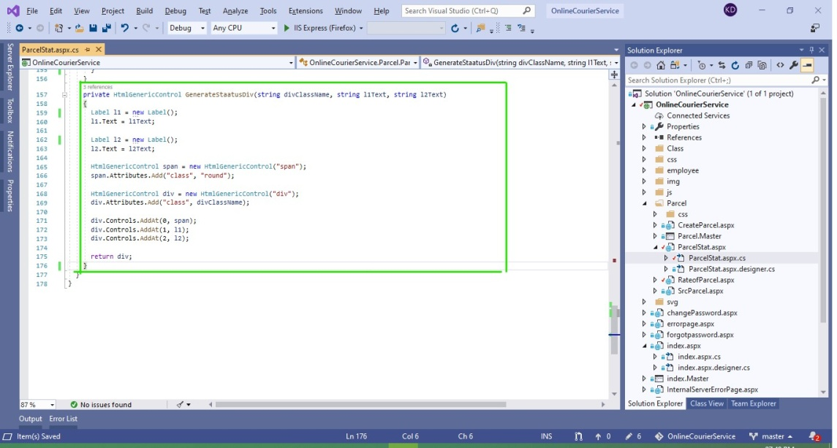

This Function creates divs dynamically, fetched from the database and shows in Parcel Stat asp pannel if provided with correct **Parcel ID**

We can see in the next picture the function is working fine as the Parcel status pannel is correctly filled up by the information based on the the Parcel ID provided as a query string.

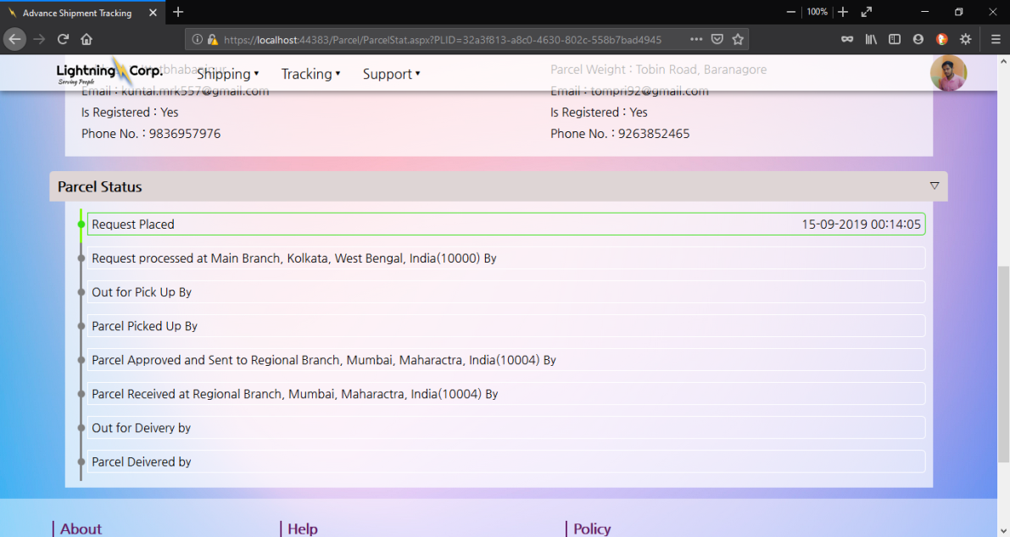

## Integration Testing

The objective is to take unit tested components and build a program structure that has been dictated by design.Integration testing is testing in which a group of components are combined to produce output.

Integration testing is of four types: (i) Top down (ii) Bottom up (iii) Sandwich (iv) Big-Bang.

**Example:**

(a) Black Box testing:- It is used for validation.

In this we ignores internal working mechanism and

focuses on **what is the output?**.

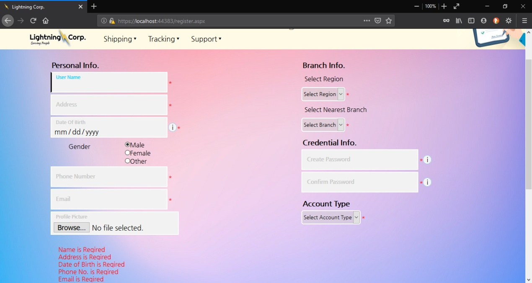

# In the previous page we saw that in the Customer registration page that if the form is not filled up coreectly it will show an red asterisk(*) next to the input field and goup all the validation error messages in the bottom.

# 

# If supplied with correct data format the data will be sent for server processing and will show, message according to it. Here we see a successful message as the user has been registered successfully.

(b) White Box testing:- It is used for verification.

In this we focus on internal mechanism i.e.

**how the output is achieved?**

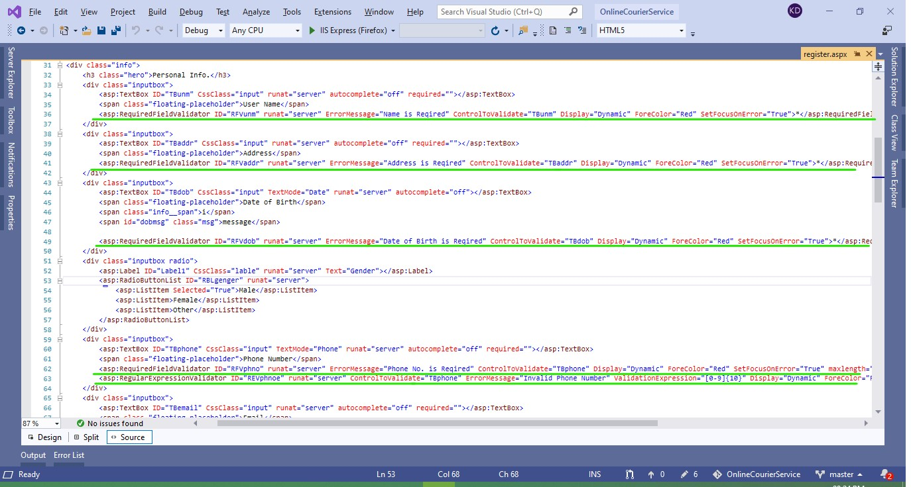

Every Here I have used diffirent Validator (**Required Field Validator**, **Regular Expression Validator** etc.) to achieve the form validation and to show messages at bottom I’ve used **Validation Summary** at the bottom of the Page.

## Regression Testing

Every time new module is added leads to changes in program. This type of testing make sure that whole component works properly even after adding components to the complete program.

**Example:**

In Customer record we supposed to have customer records who have successfully Registered through the **Customer Registration Page,** and he should be able to login to our system with his email/phnonumber and password, if the user can login and have same data in his/her profile page we can say, integration of these module works fine and the modules pass regression testing.

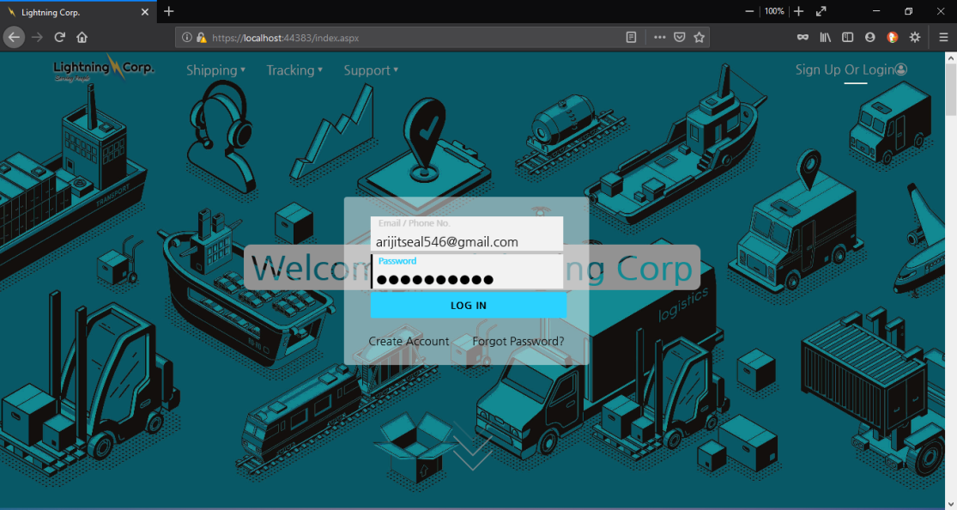

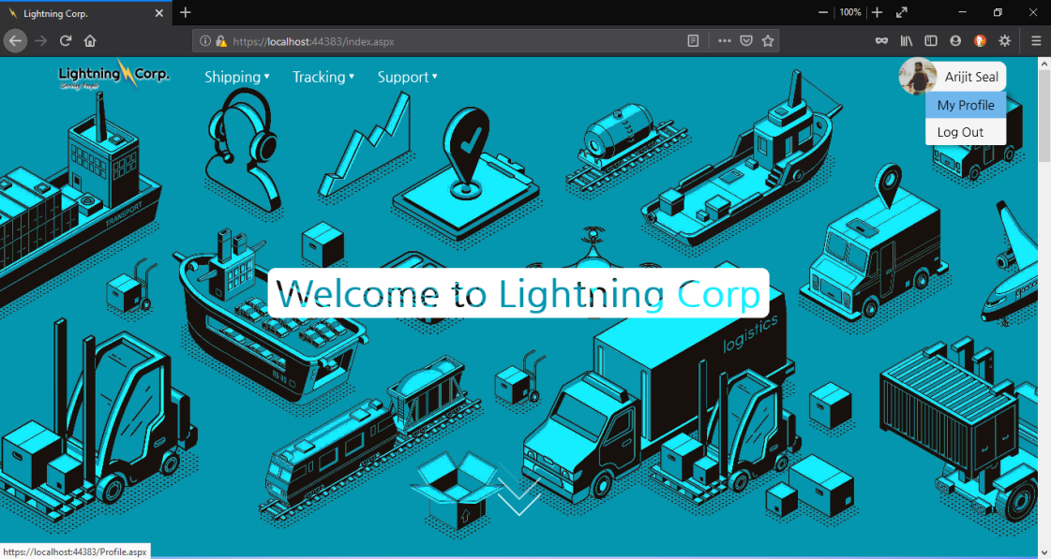

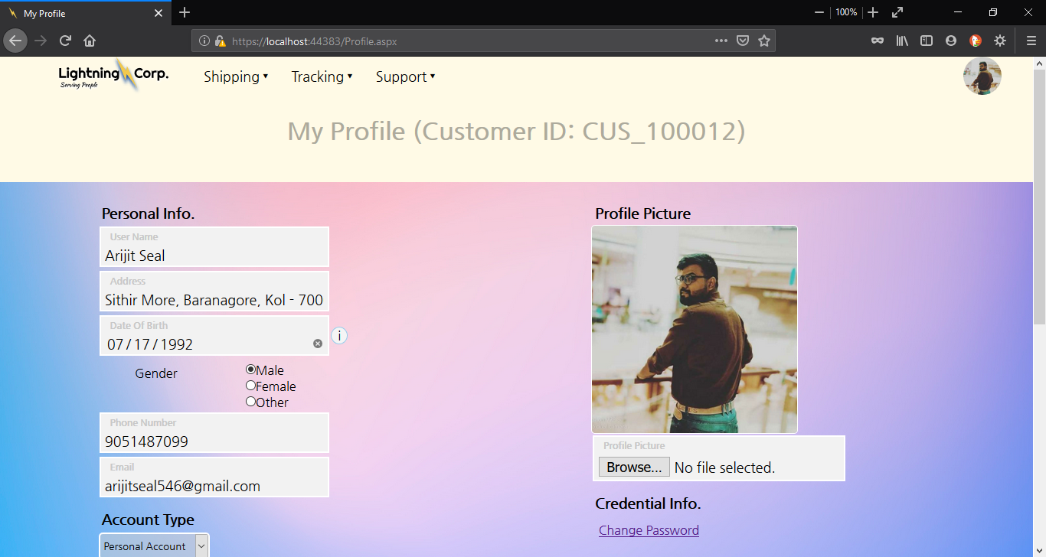

These above set of screenshots we can clearly see the cusomer account we created during integration testing has logged in successfully and all the data is same as provided in the registration page.

## System Testing

In this software is tested such that it works fine for different operating system.It is covered under the black box testing technique. In this we just focus on required input and output without focusing on internal working.  
In this we have security testing, recovery testing , stress testing and performance testing

**Example:**

Our Application is web based so it will be same user experience in every operating system as long as the OS has browser support, though Chrome or Firefox is our browser of choice but it can run on diffirent browsers.

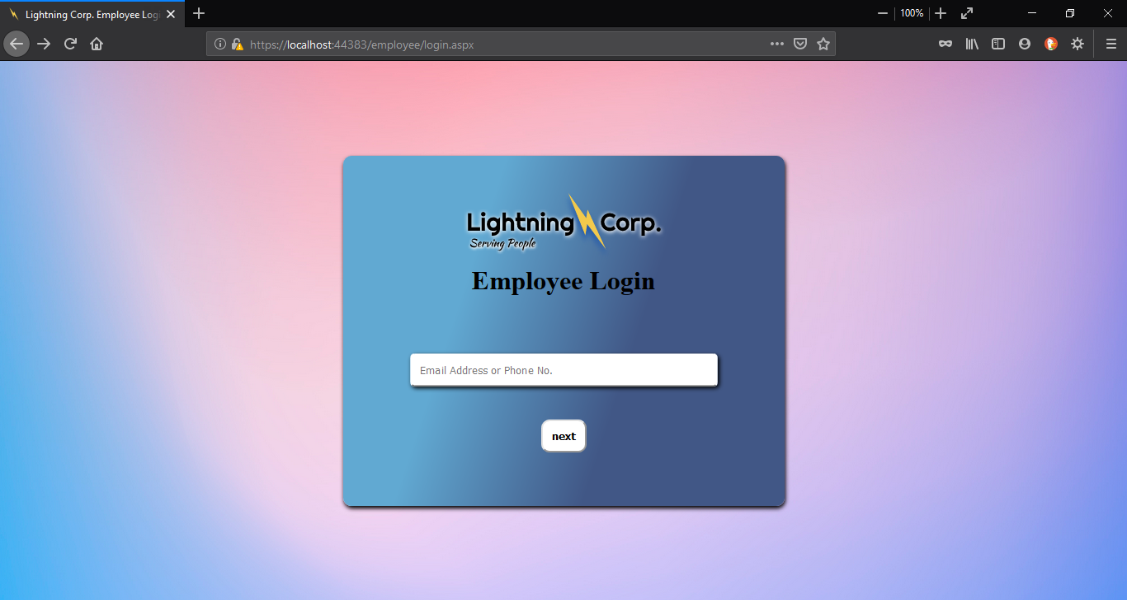

For the Admin/Employee side if any one attempts to access the pages specific to be used by admin/Employee they will be forwarded to Admin/Employee Login page instead, so it ensures system security as Admin/Employee have more privilage than any other user in the system.